St. Francis of Assisi Parish Rooms Procedures

Parish Room co-ordinator : Sarah Carroll : 01926 641638

When you arrive
- Light switches are in several parts of the building, usually by the stairs or doorway.
- Notify the Parish Rooms co-ordinator of any damage or non-functioning equipment.
- Depending on the time of year, you may wish to put the heating on. See below.

Heating Controls

Radiator controls
Each radiator is independent and has controls to turn it on or off.
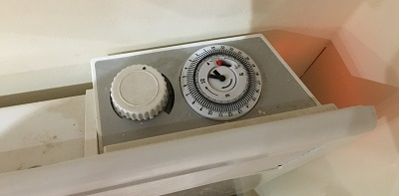
To turn on a radiator, flick the switch on the side of the radiator – hear where the orange light is showing above. Then rotate the control knob on the left clockwise until it comes on.

Toilet heater
This is left permanently on, on a low heat, and should not be altered.

In case of Fire
There are 2 fire extinguisher on the ground floor – one by the front door, and one by the bottom of the stairs.
There is a fire extinguisher on the upper floor by the large window.
- If it is a small fire, use the facilities above to put it out. Then advise the Parish rooms co-ordinator.
- If it is a large fire, leave the building in an orderly manner and congregate in the car park, sufficiently far away from any danger. Call the fire brigade immediately. Then advise the Parish rooms co-ordinator.

Kitchen facilities
The kitchen has cooker, microwave, dish-washer.

Cleaning facilities
Cleaning facilities are in the cupboard to the left of the stairs. In addition, the kitchen has cleaning cloths and liquids.

Tables and chairs
The Parish Rooms have 50 chairs and 6 tables. They are stored in the double cupboard to the left of the stairs.

Before you leave
- Clean up where you have been.
- Remove any rubbish – there are wheelie bins by the church entrance.
- Put away any crockery and pots/pans you have used. If dirty, the crockery can be put in the dish-washer and it turned on.
- Ensure the cooker and microwave is turned off.
- Turn down then switch off any radiators you had turned on/up.
- Close any open windows.
- Ensure there are no taps left on.
- Put away any tables and chairs you have used.
- Turn off all lights.
- Ensure the rear (emergency) door is closed.
- Lock the front door.
- Return the key to the Parish Rooms co-ordinator.
- Notify the Parish Rooms co-ordinator of any damage or non-functioning equipment.

